PROMISE & PRACTICE · DEEP DIVE · SOURCE ANALYSIS
The Birth of Jim Crow — A House Divided
From a Second Founding to Jim Crow
Name: ______________________________ Period: _____ Date: ________________
WHAT I CAN DO TODAY I can read primary sources about The Birth of Jim Crow — A House Divided, weigh who made each one and why, and use evidence to answer historical questions.
Directions. Compare the beginning and the end of this era. The distance between them is the whole story

THE SOURCES
THE IMAGE · 1868 — “This Is a White Man's Government”
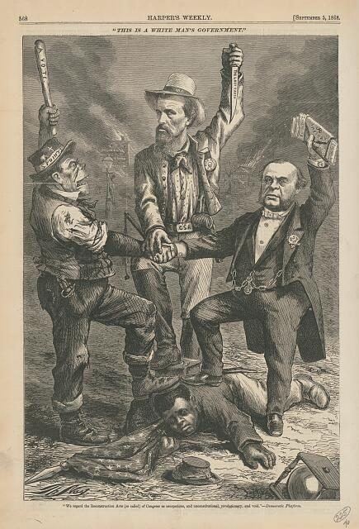
“This Is a White Man's Government” — wood engraving by Thomas Nast, Harper's Weekly, 1868, public domain (Library of Congress).
SOURCE · THE TOOLS OF JIM CROW — How rights were hollowed out
To take the vote: poll taxes, literacy tests, grandfather clauses — none mentioning race, but all aimed at Black voters (registration fell 90%+ in some states).
To enforce separation: segregation laws in schools, transit, and public life, upheld as “separate but equal” in Plessy v. Ferguson (1896).
— summarized from the historical record. Public domain
— summarized from the historical record. Public domain.

YOUR WORK
QUESTION 1 STEP 1 · BEFORE AND AFTER
Describe the South at Reconstruction's high point (Black voters and officeholders, the new amendments) versus the South under Jim Crow (disenfranchisement, segregation). What changed?
____________________________________________________________________________________________
____________________________________________________________________________________________
____________________________________________________________________________________________
QUESTION 2 STEP 2 · THE LOOPHOLE, USED
Poll taxes, literacy tests, and grandfather clauses never mentioned race. Why was that the whole point?
☐ A. to make voting easier
☐ B. because they applied equally to everyone
☐ C. to disenfranchise Black voters while technically obeying the 15th Amendment
☐ D. they had nothing to do with voting
QUESTION 3 STEP 3 · “SEPARATE BUT EQUAL”
Justice Harlan, dissenting in Plessy, called “equal” accommodations a “thin disguise.” What did he mean? Why was “separate but equal” almost never actually equal?
____________________________________________________________________________________________
____________________________________________________________________________________________
____________________________________________________________________________________________
QUESTION 4 STEP 4 · NAME THE CHANGE
In three or four sentences, describe the change over time from the “second founding” to Jim Crow. How could the nation move so far, so fast — and why did the words in the Constitution not stop it?
____________________________________________________________________________________________
____________________________________________________________________________________________
____________________________________________________________________________________________
____________________________________________________________________________________________
____________________________________________________________________________________________
Promise & Practice · ShadowDog Digital Studios · Unit 2

TEACHER ANSWER KEY — The Birth of Jim Crow — A House Divided

QUESTION 1: Open response.
Look for a response along the lines of: “At the high point…; under Jim Crow…”
QUESTION 2: Correct — C. to disenfranchise Black voters while technically obeying the 15th Amendment
Right. Because the 15th Amendment only banned denying the vote ‘on account of race,’ these race-neutral-sounding rules could disenfranchise Black voters while technically obeying the Constitution.
QUESTION 3: Open response.
Look for a response along the lines of: “Harlan meant…; in practice the facilities were…”
QUESTION 4: Open response.
Look for a response along the lines of: “In one generation the South went from ___ to ___, because…”

